LAB SESSION 12
Programming Exercise:
Question 1: Write a class Circle with a private member radius. Write a friend function to calculate the area of the circle.
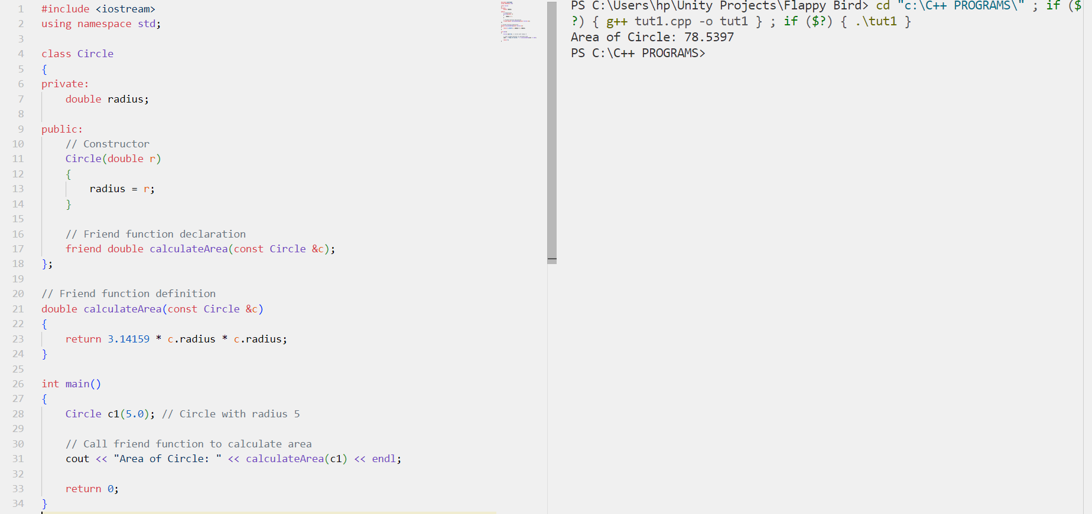

Question 2: Implement a class Rectangle with private members length and width. Write a friend function to calculate the perimeter of the rectangle.
